 



**eProject Document**

Amazing Bridges

|  |  |
| --- | --- |
| **Group 5** | |
| **Members** | Pham Minh Hien- Student1247030 (Team Leader)  Tran Khanh Duong- Student1247038  Tran Minh Quang– Student1253305  Nguyen Van Kien– Student1253297 |
| **Instructor** | Nguyen Van Luan |
| **Batch** | C1908I1 |
| **Semester** | I |

# **Hardware and Software Requirements**

### **Minimum Hardware Requirements**

* CPU: Pentium IV 2.00 GHz.
* RAM: 512 MB.
* Hard Disk: 5 GB.
* OS: Window 2000/XP/Server 2003.
* Internet Explorer 7.0 or FireFox 12.0
* Internet information services (IIS) 5.1 or higher.

### **Recommended Hardware Requirements**

* CPU: Dou Core 2.00 GHz or higher.
* RAM: 2 Gb or higher.
* Hard Disk: 80 GB or higher.
* OS: Window 7.

### **Software Requirements**

* Environment: Microsoft .NET Framework 2.0 or later
* Database Management System: Microsoft SQL Server 2005 or later
* IDE: Microsoft Visual Studio 2008 or later
* Web Server: Internet Information Services (IIS 7.0) or later
* FireFox 12.0.

# **Install Application “Amazing Br****”.**

## **Installing XAMPP**

**Step 1 :** Go to Xampp's homepage and download it

<https://www.apachefriends.org/index.html>

**Step 2 :** After downloading the installation file, run it, then select Next

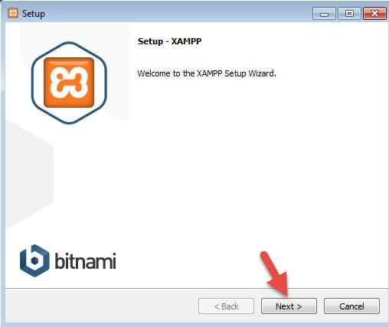

**- Step 3 :** In the path selection section, select the path to save the settings of XAMPP. Note that this path you must remember because when you install the web on localhost, you must access this directory. You should leave the default at c:\ xampp. Continue to click Next.

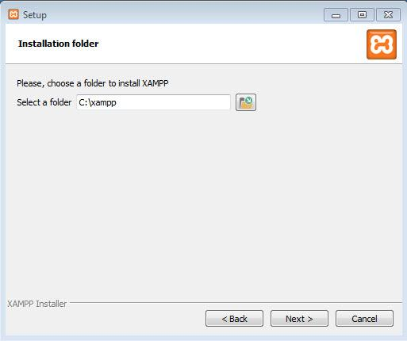

**- Step 4 :** On the next page, uncheck the "Learn more about Bitnami for XAMPP" section. And click Next 2 more times to start the XAMPP installation process.

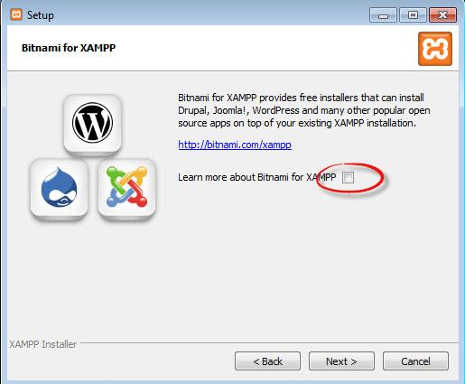

After installation, press the Finish button to finish the installation and open the XAMPP control panel. However, please restart the computer after the installation is complete to avoid the situation of not starting localhost.

**- Step 5 :** Start Localhost

Now go to the directory c: \ xampp and open the file xampp-panel.exe to turn on the control panel of XAMPP.

**- Step 6: Start Apache**

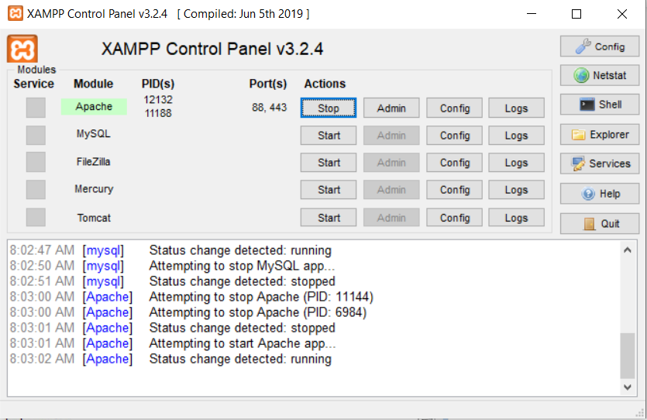

**- Step 6:** Copy the extracted project to http://localhost:port-number/name-folder/

Note:

**1.** post-number : 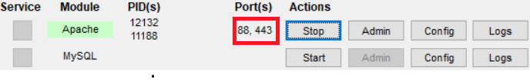

**2.** name-folder: The project name has been extracted.

## **User Guide**

##### ***Start Login***

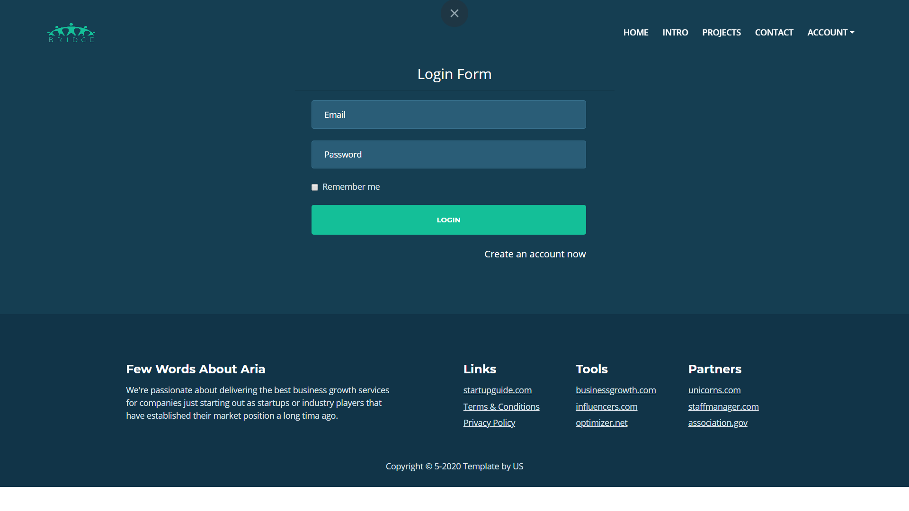

1. If you do not have an account, click Create an account now.

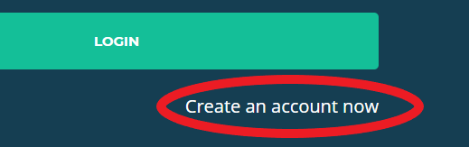

# 2. At the registration page, enter the information and click Register

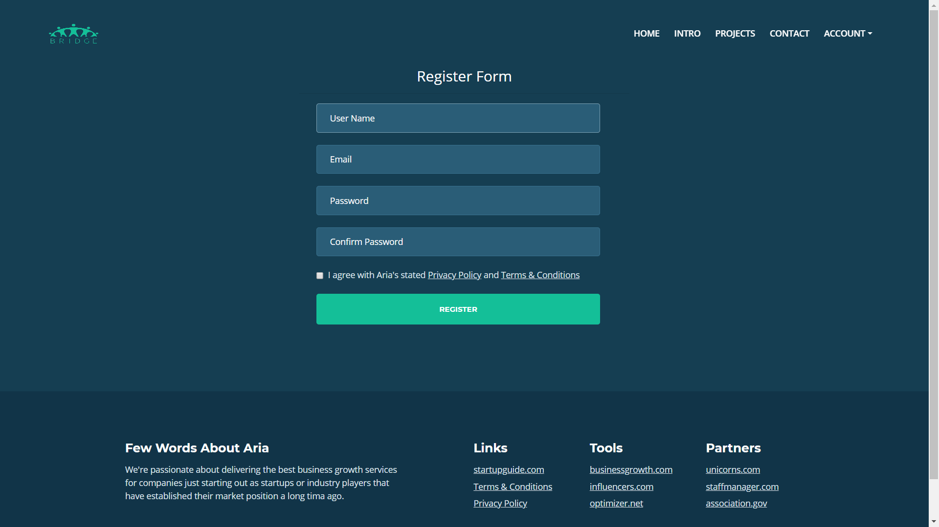

1. After registering, you will be redirected to the login page, enter the information you have just registered, then click login. After logging in you will be redirected to the home page.(*If you already have an account, skip the 2 steps above*).

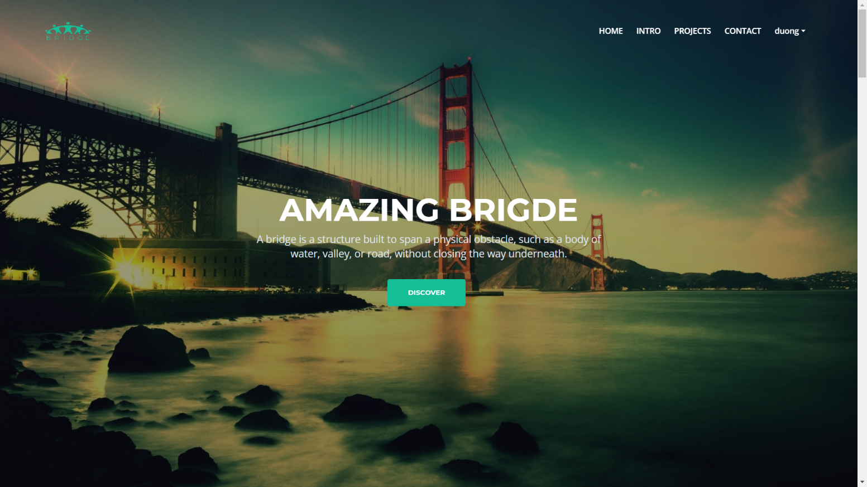

##### ***User Functions***

You have the option to display the types of bridges

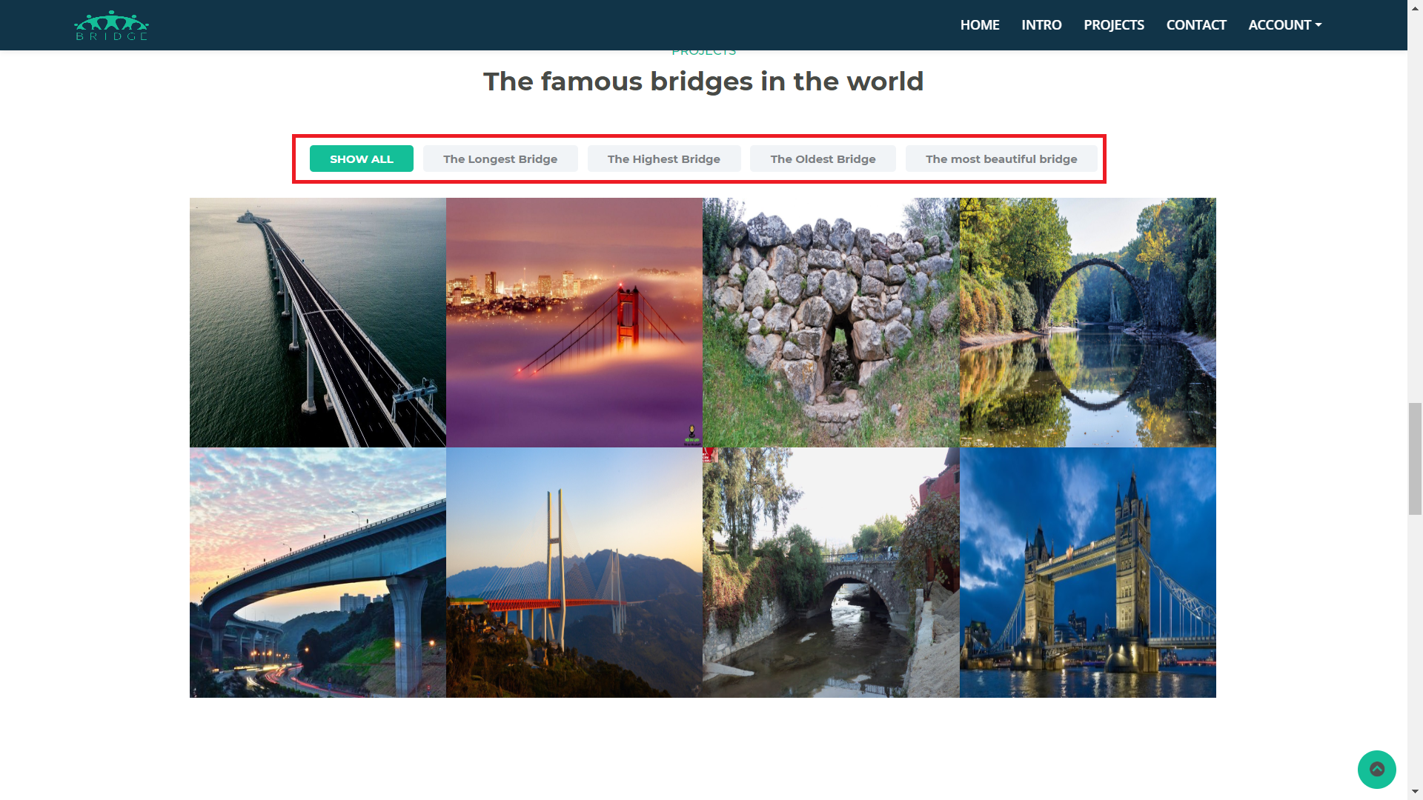

Click on any image to view the article about the bridge

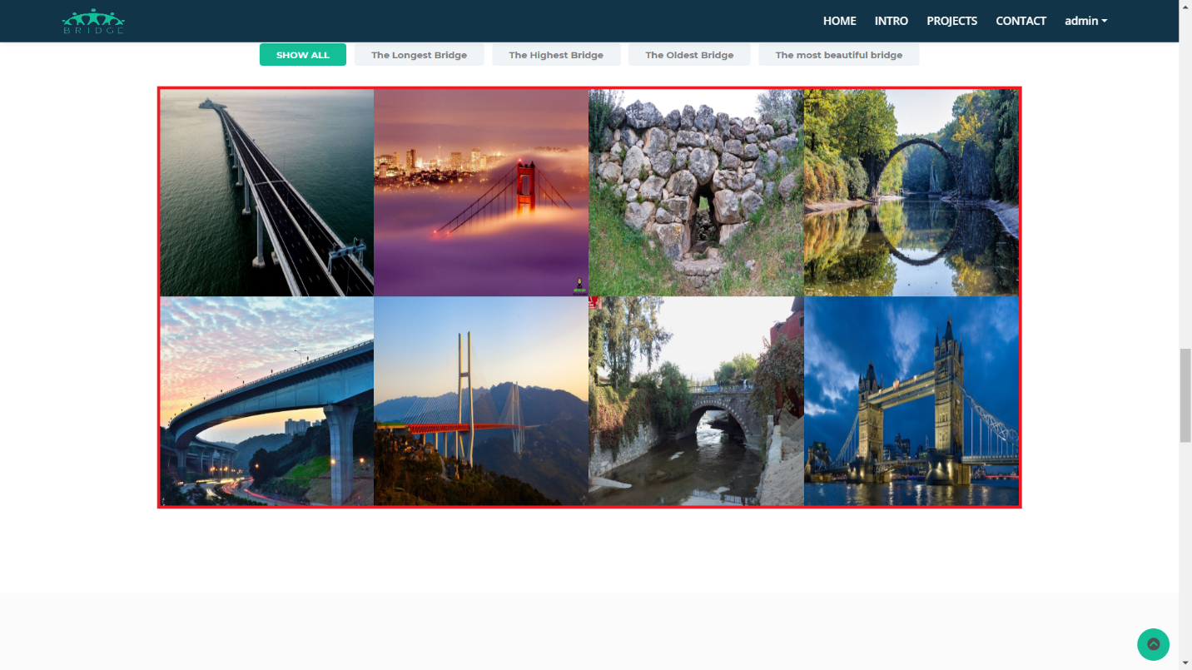

In detail every bridge you can see : description of the bridge

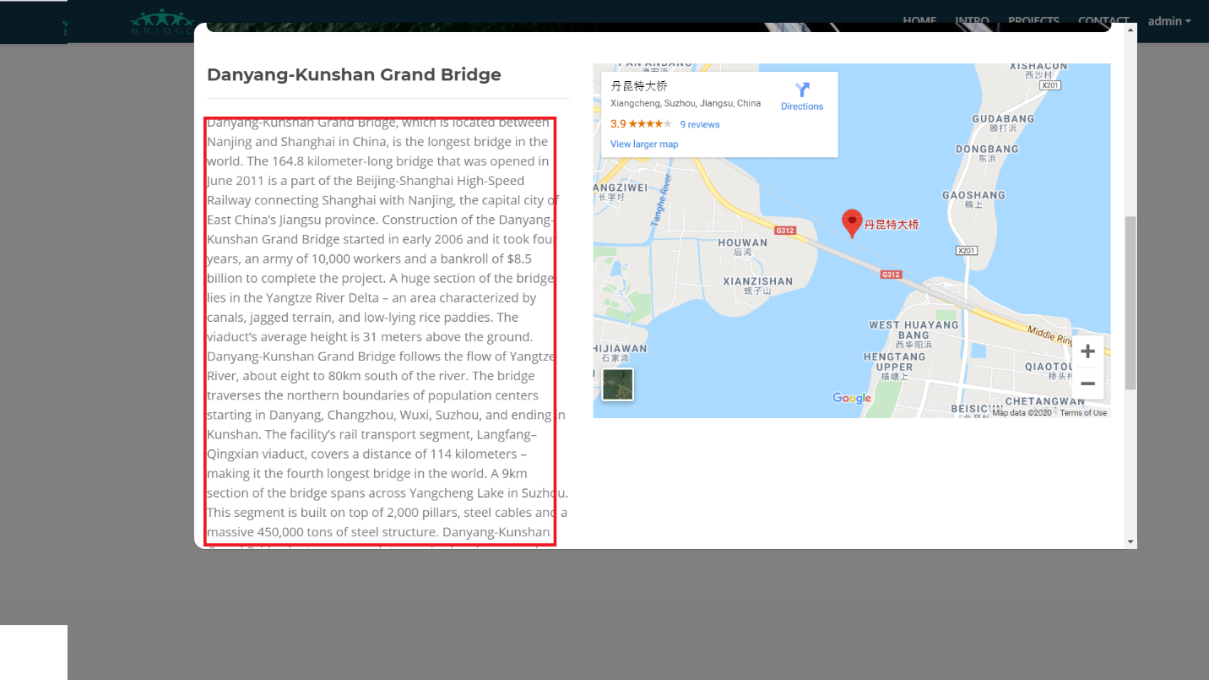

map and directions to there

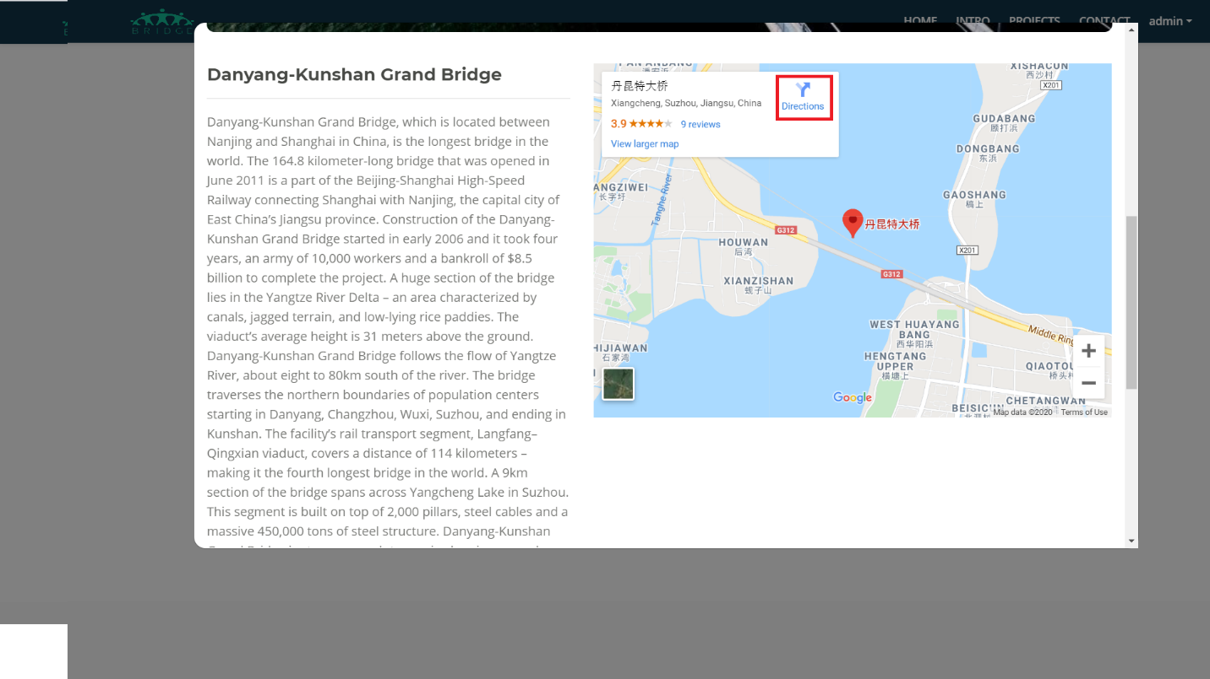

Download the bridge document

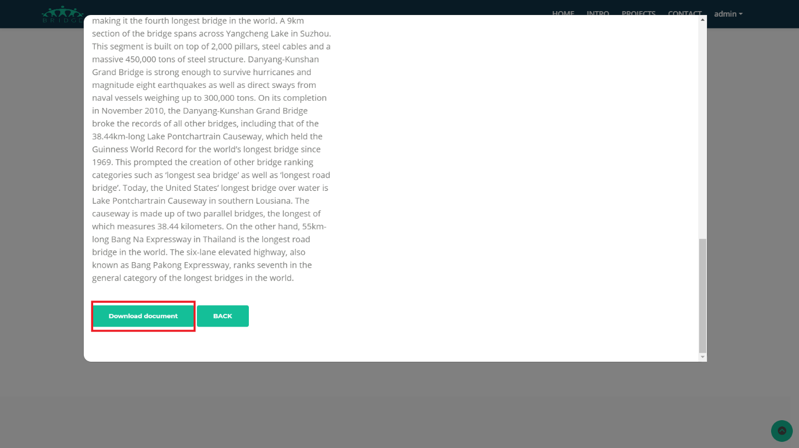

If you have any ideas, please send us an email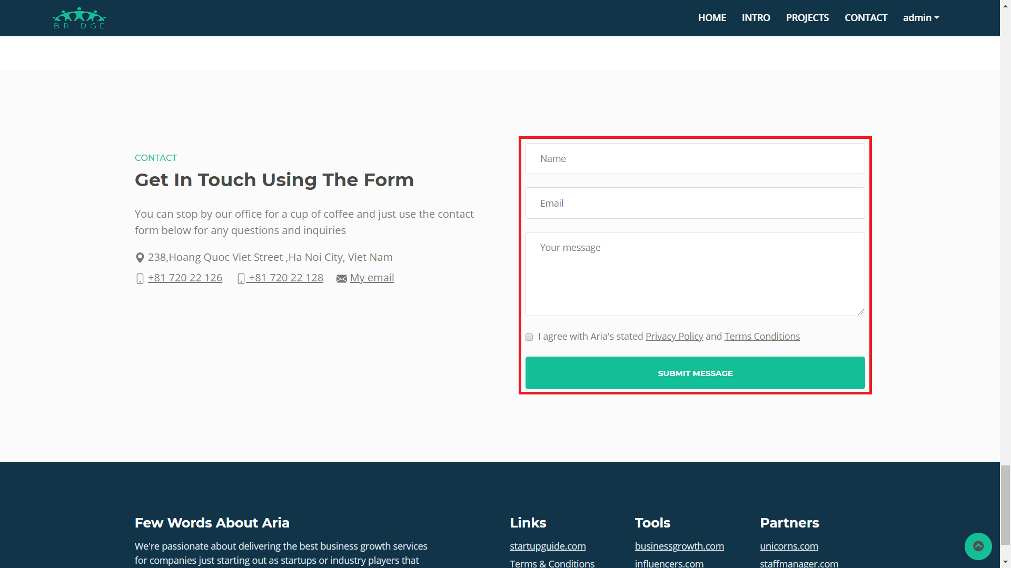

**THE END**